Submitted by-

Name- Ishan Rawat

SAP ID- 500087524

Roll no- R2142201888

Application Containerization and Orchestration Experiment 6

**Aim:**  Working with Docker Compose File to Control Multiple Containers

Step 1: Create a directory named nginx in your root.

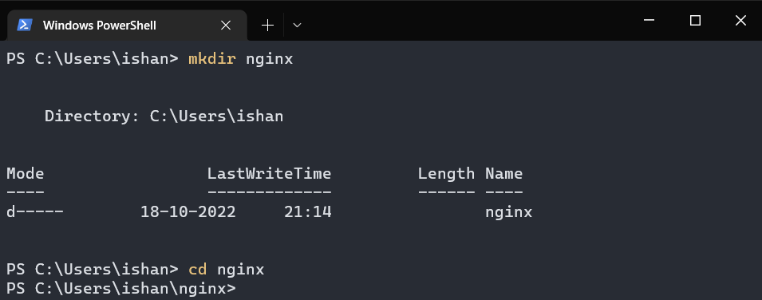

Step 2: Switch to that directory and create a file named docker-compose.yaml

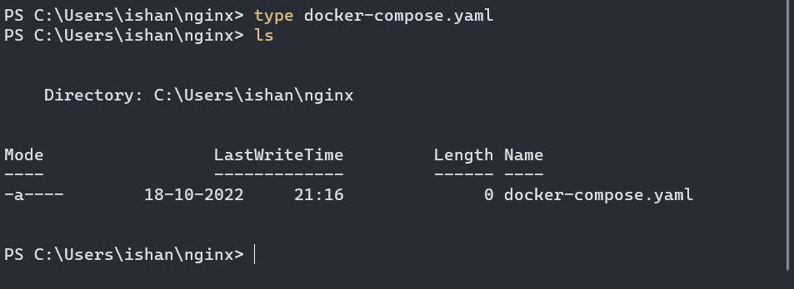

Now in the Yaml file add the following commands :-

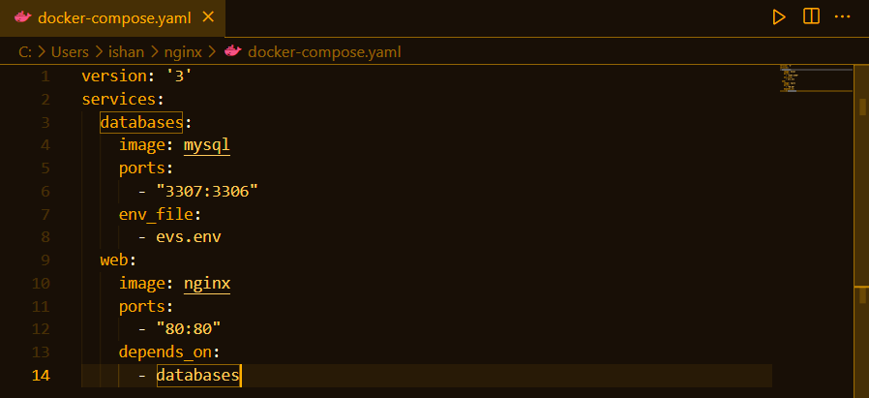

Step 3: Now create a file that will contain credentials.

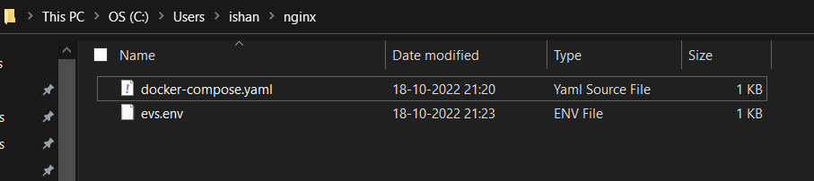

Now add the following credentials in the evs.env file :-

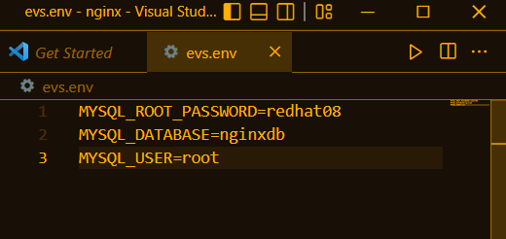

Step 4: Running images using docker-compose

Run the command: docker-compose up –d

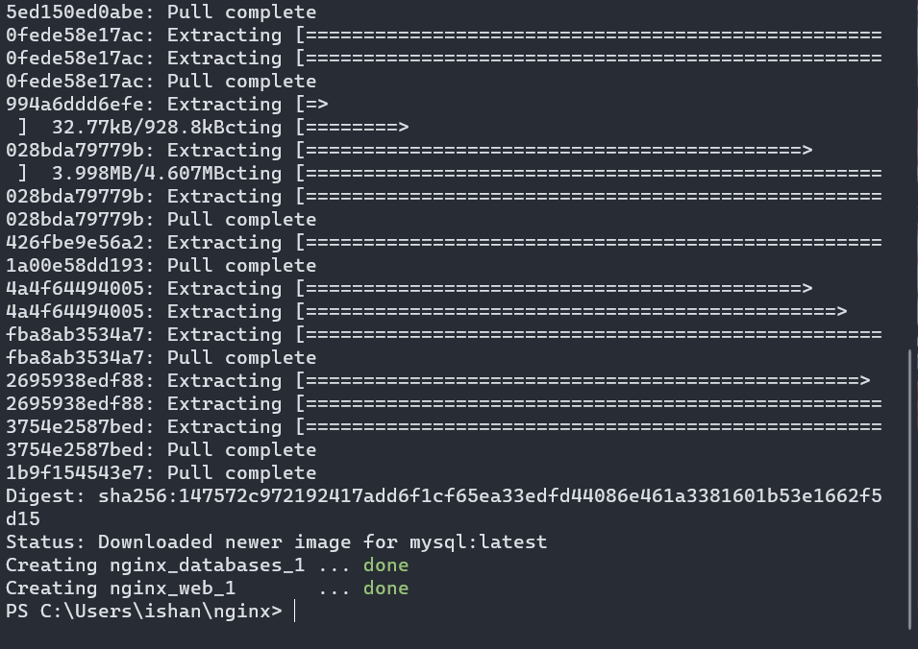

Step 5: Verify nginx service is up and is accessible on machine.

Run the command: curl localhost:80

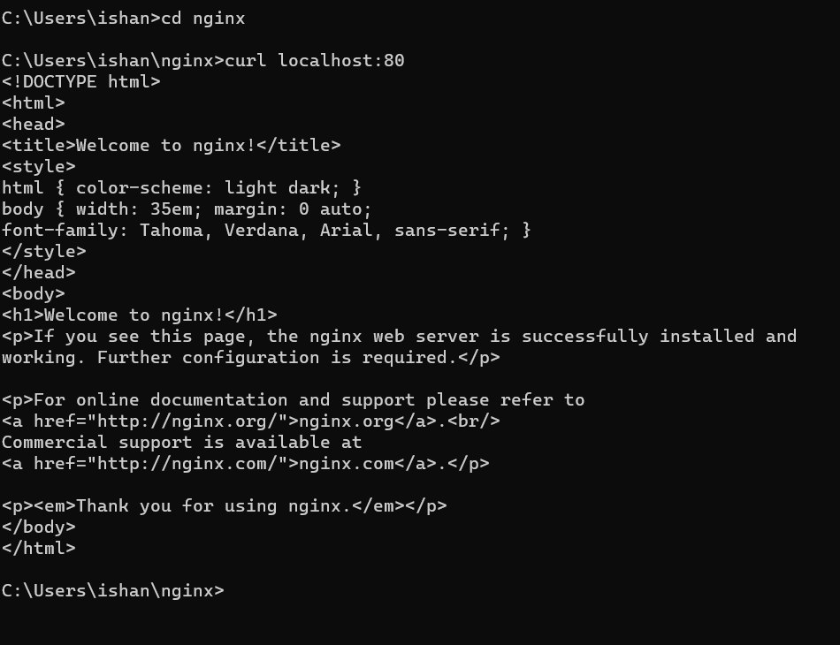

On the web if we enter the url: localhost:80 we should see something like:

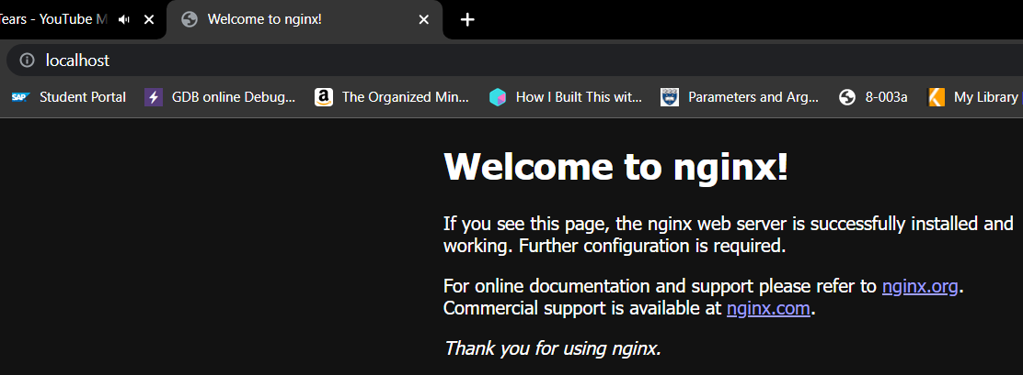

Step 6: Stop and remove your docker container using docker-compose

Run the command: docker-compose down

